

Project Title: Comparative Financial Statement Analysis of Safe Mix Concrete and Thatta Cement
Submitted By:

Student Name | Muhhammad Dawood Hayat
Registration number | FA24-BBD-220
Subject | Business finance ( BF )
Semester | 3 rd
Section | 3 C
University | Comsats University Islamabad
Program: Bachelor of Business Data Analytics (BDA), 4th Semester
Course: Business Finance (Spring 2026)
Department of Management Sciences COMSATS University Islamabad

Contents
Chapter 1: Introduction 2
Chapter 2: Trend Analysis 3
2.1 Introduction 3
Liquidity Ratios 3
2.2 Current Ratio 4
2.3 Acid Test (Quick) Ratio 4
Financial Leverage / Debt Ratios 4
2.4 Total Debt to Equity 5
2.5 Total Debt to Total Asset 6
2.6 Long Term Debt to Total Capital 6
Coverage Ratios 6
2.7 Times Interest Earned 6
Activity Ratios 6
2.8 Receivable Turnover 8
2.9 Average Collection Period 8
2.10 Payable Turnover 8
2.11 PTO in Days 8
2.12 Inventory Turnover 9
2.13 ITO in Days 9
2.14 Operating Cycle 9
2.15 Cash Cycle 9
2.16 Total Asset Turnover 9
Profitability Ratios 9
2.17 Gross Profit Margin 10
2.18 Net Profit Margin 11
2.19 Return on Investment (ROA) 11
2.20 Return on Equity (ROE) 11
2.21 Chapter Discussion and conclusion 11
Chapter 3: Common Size Analysis for Three Recent Years 11
Chapter 4: Index Analysis for the Three Recent Years 12
Chapter 5: Risk and Return Assessment 13
Chapter 6: Conclusion 14
References 15

List of Tables

Table 1 : Liquidity Ratios 4
Table 2 : Solvency and Debt Ratios 5
Table 3 : Coverage Ratios 7
Table 4 : Activity Ratios 7
Table 5 : Profitability Ratios 10
Table 6 : Common Size Analysis 12
Table 7 : Index Analysis 13
Table 8 : Risk and Return Calculations 14

List of Figures

Figure 1: Liquidity Ratios 4
Figure 2 : Solvency Ratios 6
Figure 3 : Activity Ratios (Days) 8
Figure 4 : Profitability Ratios 11

Chapter 1: Introduction
To understand a company’s financial health, we have to look beyond the top line revenue and observe how the management is managing its physical assets, structuring its debt, and operating day-to-day operations. This research is about the financial reality of Safe Mix Concrete (SMC), a ready-mix concrete manufacturer and supplier to the building industry. To determine where SMC is headed, we examined the audited financial performance of SMC throughout a 3-year period, 2023 to 2025.
To provide a reasonable benchmark for study of SMC’s performance in 2025, SMC’s performance was placed with Thatta Cement. Comparing a ready mix concrete supplier to a cement plant directly is great perspective. Both companies operate in the same macroeconomic environment and depend on the same heavy construction demand in the country.
We pulled the annual reports for both companies and extracted the raw income statements and balance sheets so we could calculate a full suite of financial ratios. We then took the financials and scaled them using common size and index analysis to determine exactly how internal expenses are acting over time. Finally, we collected 65 days of historical daily stock market data to see how the stock exchange prices the risk and return of these companies in real-time.

Chapter 2: Trend Analysis

2.1 Introduction
Trend analysis tells you whether management is making the firm better year after year, or gradually losing ground. We took our ratio study and divided it down by various financial categories, looking at everything from basic survival measures to deep profitability returns. This structure clearly indicates where SMC is winning and where Thatta Cement has the competitive advantage.

Liquidity Ratios
Table 1: Liquidity Ratios
Table 1 : Liquidity Ratios
Ratio Name | Assigned Company (SMC) Year 1: 2023 | Assigned Company (SMC) Year 2: 2024 | Assigned Company (SMC) Year 3: 2025 | Competitor Name (Thatta) Year 3: 2025
Current Ratio | 1.09 | 1.43 | 1.38 | 2.41
Quick Ratio | 1.02 | 1.34 | 1.33 | 2.38
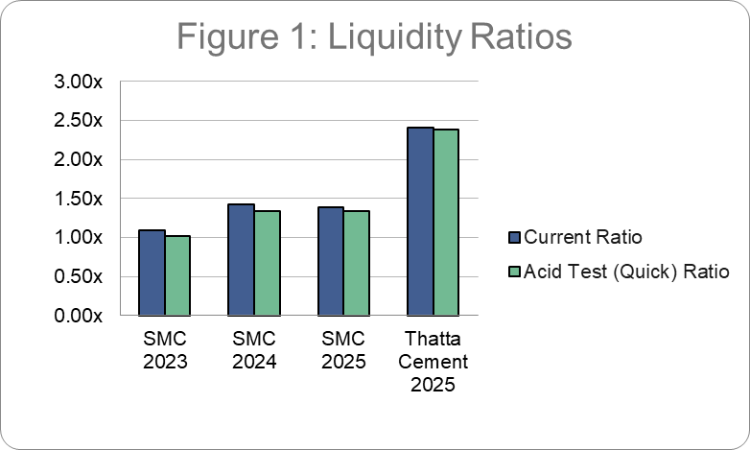
Figure 1: Liquidity Ratios

2.2 Current Ratio
Results: SMC’s current ratio has improved from 1.09 in 2023 to 1.38 in 2025. Thatta Cement is sitting much higher at 2.41. Interpretation: The current ratio is a basic measure of survival that checks if a company has enough short-term assets to pay its short-term bills. SMC has managed to build a better buffer in the last three years. Back in 2023, they had just enough current assets to cover immediate liabilities, which leaves no room for error. While SMC is safe now, Thatta Cement operates with a massive safety net. Holding more than double the assets they need to pay their obligations within the next year gives Thatta incredible operational flexibility.

2.3 Acid Test (Quick) Ratio
Results: SMC’s quick ratio increased from 1.02 to 1.33. Thatta Cement is at 2.38. Interpretation: The Quick ratio excludes inventory from the current ratio since inventory may not be easily liquidated rapidly in an emergency. SMC doesn’t keep huge stocks of finished concrete products either as concrete is a perishable product that is mixed and delivered on demand. Their quick ratio is almost the same as their current ratio at 1.33. They are extremely liquid without needing to sell any stock.

Financial Leverage / Debt Ratios
Table 2: Solvency and Debt Ratios
Table 2 : Solvency and Debt Ratios
Ratio Name | Assigned Company (SMC) Year 1: 2023 | Assigned Company (SMC) Year 2: 2024 | Assigned Company (SMC) Year 3: 2025 | Competitor Name (Thatta) Year 3: 2025
Total Debt to Equity | 171.60% | 110.68% | 123.54% | 42.05%
Total Debt to Total Asset | 63.18% | 52.53% | 55.27% | 29.60%
LT Debt to Total Capital | 25.24% | 13.43% | 17.97% | 0.00%
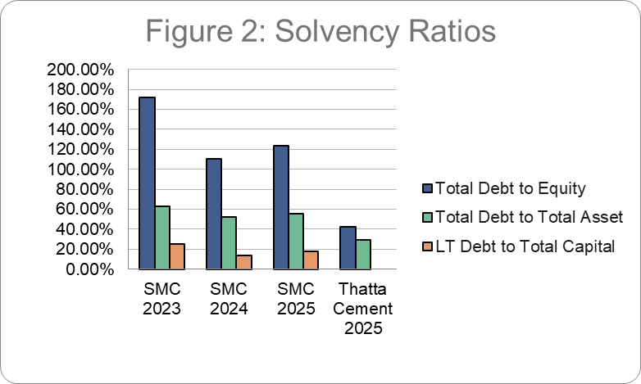
Figure 2 : Solvency Ratios

2.4 Total Debt to Equity
Results: SMC has a ratio of 171.60% in 2023, which decreased to 123.54% in 2025. Thatta is operating at only 42.05%. Interpretation: Solvency is an indicator of how reliant a company is on debt. This is the serious financial danger that SMC presents. If debt is larger than equity the lenders effectively have a larger financial claim on the business than the owners themselves. They are paying this down but it is a stark comparison with Thatta Cement and the aggressive financing strategy SMC has in place.

2.5 Total Debt to Total Asset
Results: In 2025, debt finances 55.27% of assets of SMC. Thatta Cement 29.60 per cent. Interpretation: This indicator measures the percentage of the total assets of the company that is funded by creditors. More than half of what that SMC holds is in debt finance. Thatta Cement is significantly safer as debt is less than 1/3rd of their whole asset base.

2.6 Long Term Debt to Total Capital
Results: The SMC in 2025 is 17.97%. Thatta Cement was unchanged at 0.00 %. Interpretation: This ratio is based on long-term borrowings. SMC still depends on long term bank loans to finance their big machineries and mixing plants. A check of Thatta’s balance sheet shows it has no secured long-term financing. They are financing their long term expansion 100% with equity . They are very resistant to interest rate spikes .

Coverage Ratios
Table 3: Coverage Ratios
Table 3 : Coverage Ratios
Ratio Name | Assigned Company (SMC) Year 1: 2023 | Assigned Company (SMC) Year 2: 2024 | Assigned Company (SMC) Year 3: 2025 | Competitor Name (Thatta) Year 3: 2025
Times Interest Earned | 6.69x | 3.99x | 5.07x | 39.12x

2.7 Times Interest Earned
Results: Interest coverage ratio of SMC was 6.69 times, 2023 and 5.07 times in 2025. Thatta’s interest coverage is at 39.12 times. Interpretation: This ratio measures the ability of operating profit to cover mandatory interest expenses. SMC lost some of its safety margin with operating profits down and finance cost still high reflecting the huge debt load noted previously. Thatta Cement has very little long term debt therefore their interest expense is modest and they can easily cover it.

Activity Ratios
Table 4: Activity Ratios
Table 4 : Activity Ratios
Ratio Name | Assigned Company (SMC) Year 1: 2023 | Assigned Company (SMC) Year 2: 2024 | Assigned Company (SMC) Year 3: 2025 | Competitor Name (Thatta) Year 3: 2025
Receivable Turnover | 4.34x | 3.63x | 4.35x | 45.48x
Avg Collection Period | 84 days | 100 days | 84 days | 8 days
Payable Turnover | 5.12x | 5.23x | 4.59x | 4.01x
PTO in days | 71 days | 70 days | 79 days | 91 days
Inventory Turnover | 43.57x | 33.85x | 65.90x | 87.02x
ITO in days | 8 days | 11 days | 6 days | 4 days
Operating Cycle | 93 days | 111 days | 89 days | 12 days
Cash Cycle | 21 days | 41 days | 10 days | -79 days
Total Asset Turnover | 1.92x | 1.57x | 1.66x | 0.80x
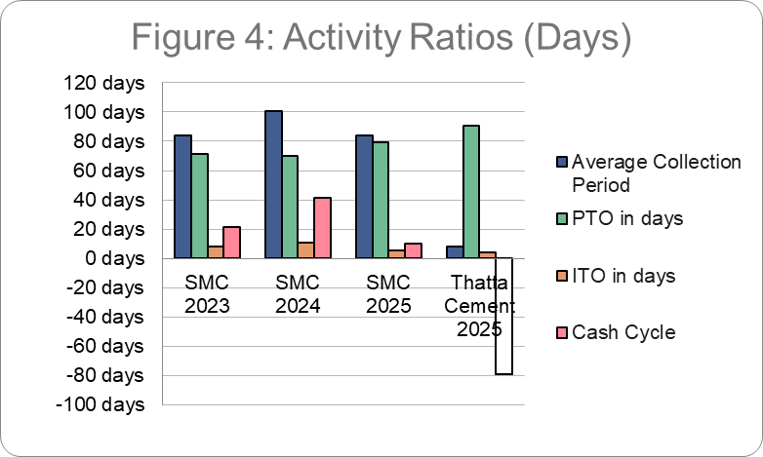
Figure 3 : Activity Ratios (Days)

2.8 Receivable Turnover
Results: SMC turns over receivables 4.35 times per year. Thatta turns them over 45.48. Interpretation: How quickly a corporation obtains cash from its customers. For SMC, a slower turnover is somewhat predicted in the construction business with project delays and contractors holding back payments. However, Thatta Cement is quite efficient in its collection section.

2.9 Average Collection Period
Results: Cash collection takes 84 days for SMC. Thatta collects in 8 days. Interpretation: The real-world day-to-day turnover becomes more transparent. SMC has to wait approximately three months to get cash after delivering concrete. Thatta Cement has huge market power, and they force their buyers to pay practically quickly.

2.10 Payable Turnover
Results: SMC pays suppliers 4.59x each year. Thatta, 4.01 times a year. Interpretation: This is the frequency with which the corporation pays its own bills. Both corporations are trying to hold on to their cash as long as possible before paying vendors.

2.11 PTO in Days
Results: SMC pays its bills in 79 days. Thatta for 91 days Interpretation: Both firms use their suppliers as a source of short-term finance without interest. Stretching payables is a standard practice in heavy manufacturing to protect internal cash flow.

2.12 Inventory Turnover
Results: SMC inventory turns 65.90 times/yr. Thatta is at 87.02 times. Interpretation: These large numbers are totally reasonable. Ready-mix concrete is delivered the same day it is mixed. SMC only stocks raw sand, gravel and cement and this is used constantly to complete daily requests.

2.13 ITO in Days
Results: Inventory cleared by SMC in 6 days. Thatta in 4 days. Interpretation: Less than a week’s storage of your supplies in the yard is good supply chain management and means cash isn’t stuck in unused inventories.

2.14 Operating Cycle
Results: The SMC cycle is 89 days. Thatta is accomplished in 12 days Interpretation: The operating cycle is the sum of inventory days and collection days. SMC’s cycle is almost completely driven by sluggish collections from contractors.

2.15 Cash Cycle
Results: The cash cycle of SMC is positive i.e. 10 days. Thatta has a negative cash cycle of 79 days. Interpretation: The cash conversion cycle is the most telling statistic in our data. SMC pays its invoices on about day 79 and gets reimbursed on about day 89. So there is a 10 day gap where they have to fund their own operations. Negative cash cycle provides tremendous competitive advantage to Thatta Cement. They obtain cash from buyers in 8 days, but wait 91 days to pay suppliers. They have the cash sitting in their bank accounts for almost 3 months before they actually pay for the materials. They are basically working on the money of their suppliers.

2.16 Total Asset Turnover
Results: SMC earns a revenue of Rs.1.66 for each rupee of assets. Thatta gets 0.80 Rupees for every asset. Interpretation: SMC has better turnover since it has a lower asset base relative to its sales volume than a huge heavy-industry cement facility. SMC’s assets are mostly mixing vehicles.

Profitability Ratios
Table 5: Profitability Ratios
Table 5 : Profitability Ratios
Ratio Name | Assigned Company (SMC) Year 1: 2023 | Assigned Company (SMC) Year 2: 2024 | Assigned Company (SMC) Year 3: 2025 | Competitor Name (Thatta) Year 3: 2025
Gross Profit Margin | 22.43% | 20.60% | 15.52% | 28.42%
Net Profit Margin | 9.31% | 8.84% | 6.22% | 33.79%
Return on Investment | 17.90% | 13.85% | 10.34% | 26.87%
Return on Equity | 48.62% | 29.19% | 23.12% | 38.17%
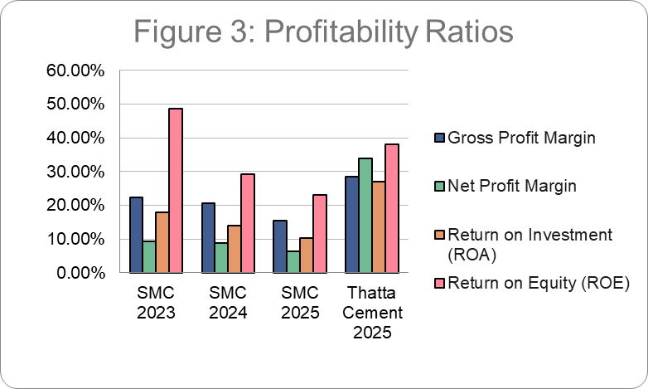
Figure 4 : Profitability Ratios

2.17 Gross Profit Margin
Results : SMC gross margin declined significantly from 22.43% in 2023 to 15.52% in 2025. Interpretation: Profit margins are the actual money that remains after direct expenses. SMC is having a tough time here. The direct cost of manufacturing concrete is become a lot more expensive, probably due to raw material inflation or higher fuel expenses for their mixer trucks, and they're straining to pass those costs on to their buyers.

2.18 Net Profit Margin
Results: SMC’s net margin decreased from 9.31% to 6.22%. Thatta has net margin of 33.79%. Interpretation: SMC's gross margins were squeezed, therefore it is no surprise that net margins were too. Here Thatta Cement is an interesting exception. In fact, their net margin is more than their gross margin. Looking over their revenue statement I saw they have a line for "Other Income" that this year was about 2 billion rupees. The huge net profit was not merely from their everyday cement activities but from an outside capital investment.

2.19 Return on Investment (ROA)
Results: SMC dropped steadily from 17.90% to 10.34%. Thatta scored 26.87%. Interpretation: return on assets measures the efficiency of management in using the company's equipment to produce profit. The trend down for SMC is simply an indication of their declining net income the past 3 years.

2.20 Return on Equity (ROE)
Results: SMC gave 48.62% return in 2023, falling to 23.12% in 2025. Interpretation: ROE is valued the most by shareholders. SMC generated an excellent return to its shareholders in 2023. But as production costs climbed and earnings fell, the return declined by more than half. Though 23% is still a good return, the rapid down trend is a huge warning indicator for investors.

2.21 Chapter Discussion and conclusion
The trend analysis proves two distinct financial narratives. Safe Mix Concrete is generating sales and paying its short-term liabilities, but the company is bogged down by heavy leverage and severely shrinking profit margins. The rising cost of daily operations is eating away at shareholder returns. In contrast, Thatta Cement is dominating. They operate with zero long-term debt, they use a negative cash cycle to trap supplier capital for their own use, and they generate massive net profitability.

Chapter 3: Common Size Analysis for Three Recent Years
Results Common size (vertical) analysis converts the raw numbers into percentages, setting total revenue at 100%. This is the best way to see exactly where a company is losing its money internally.
Table 6: Common Size Analysis (Key Income Statement & Balance Sheet Items)
Table 6 : Common Size Analysis
Financial Line Item | SMC (2023) | SMC (2024) | SMC (2025)
Revenue - net | 100.00% | 100.00% | 100.00%
Cost of sales | 77.57% | 79.40% | 84.48%
Gross profit | 22.43% | 20.60% | 15.52%
Administrative expenses | 3.16% | 3.90% | 3.49%
Profit after taxation | 9.31% | 8.84% | 6.22%
TOTAL ASSETS | 100.00% | 100.00% | 100.00%
Total Equity | 36.82% | 47.47% | 44.73%
Total Current liabilities | 49.06% | 41.82% | 42.19%
Discussion and Conclusion This vertical analysis tells us the exact reason for the fall in SMC’s profits. The core Cost of Sales as a % of their total sales in 2023 was 77.57%. By 2024, it had climbed up to 79.40%. By 2025, no less than 84.48% of every rupee they earned was channeled directly into basic production expenditures.
The basic cost of building concrete is eating up so much space on the revenue statement that there is very little room left over to meet operating expenses, loan interest and taxes. Their administrative and selling expenses barely shifted in the three years, maintaining steady at roughly 3.5%. The financial impact is occurring entirely at the gross production level. Management is suffering from substantial inflation in materials or gasoline and they can't increase the

Chapter 4: Index Analysis for the Three Recent Years
Results Index (horizontal) analysis tracks growth by setting the oldest year (2023) as a base of 100%. This reveals the growth trajectory of the business components relative to each other.
Table 7: Index Analysis (Horizontal Trends)
Table 7 : Index Analysis
Financial Line Item | SMC Index (2023) | SMC Index (2024) | SMC Index (2025)
Revenue - net | 100.00% | 88.16% | 115.36%
Cost of sales | 100.00% | 90.25% | 125.65%
Gross profit | 100.00% | 80.95% | 79.79%
Profit after taxation | 100.00% | 83.68% | 77.01%
TOTAL ASSETS | 100.00% | 108.14% | 133.30%
Discussion and Conclusion The index analysis validates the harmful structural pattern revealed in the common size analysis. On the surface, SMC’s sales volume appears quite good. Revenue fell to 88.16% of the base year in 2024, but recovered strongly in 2025 to 115.36%. A 15% increase in top-line revenue over the base year seems like a winner.
The issue was that the expense of producing those sales increased far more rapidly than the revenue itself. The Cost of Sales Index by 2025 was 125.65%. Cash going to the bottom line is getting smaller because expenses are expanding faster than sales. The Profit After Taxation index decreased continuously to 77.01% in 2025. Basically SMC is mixing and delivering 15% more concrete than two years ago, merely to generate 23% less profit. This is basically an unsustainable path of progress.

Chapter 5: Risk and Return Assessment
Results Accounting ratios are based on the previous performance of a company, while the stock market prices are based on what investors think is happening currently. To get the market realities, we gathered the historical stock prices of SMC and Thatta Cement for the last 65 days. We quantified daily price volatility by calculating the standard deviation manually with variance algorithms and confirmed the results using Excel.

Table 8: Risk and Return Calculations (65-Day Daily Trading)
Table 8 : Risk and Return Calculations
Metric | Safe Mix Concrete (SMC) | Thatta Cement
Count (Trading Days) | 65 | 65
Average Return (Mean) | -0.07% | -0.22%
Standard Deviation (Risk) | 3.74% | 3.67%
Variance | 0.0014 | 0.0013
Coefficient of Variation (CV) | -5045.47% | -1696.82%
Discussion and Conclusion Both companies have virtually the same daily price risk. SMC with 3.74% and Thatta with 3.67% standard deviation. The return is the true problem. The two firms have had negative average daily return over past three months (-0.07% for SMC and -0.22% for Thatta).
The returns are less than 0 . The CV is the standard deviation divided by the mean . When you divide by a negative number you get huge , distorted negative percentages . A negative CV signals to prospective investors that these equities are not functioning as short-term assets at the moment. Buyers are facing price volatility of roughly 4% every day simply to lose money on average. Thatta Cement boasts a stellar accounting balance sheet, but the entire construction sector is getting hammered by the larger stock market.

Chapter 6: Conclusion
This comparative financial exercise highlights a dramatic divergence between balance sheet fundamentals and short-term stock market realities.
Thatta Cement is operationally a better business. They manage their working capital with amazing aggressiveness and efficiency. They can force a negative cash cycle so they can utilize supplier money to pay their daily operations. This explains clearly why they can run a huge industrial enterprise with no long term debt. Very liquid and make a lot of money.
Safe Mix Concrete is in a serious profit squeeze at present. Their management was able to boost up sales volume in 2025 but their bottom line is being killed by the rising cost of sales. They are using a ton of leverage huge keep the business going. This is a drag on their net income with large interest payments on a regular basis. They are working more to earn less.
But our risk and return analysis shows that a strong accounting is not a guarantee of good stock returns. The stocks of both corporations have been falling day after day on the stock exchange. Investors are accepting price volatility daily without any financial gain as long as the macro-economic environment for building does not get better. The SMC management needs to urgently address their raw material costs and pricing power going forward, if they want to prevent their profit margins from leaking out completely.

References
Brigham, E. F., & Houston, J. F. (2021). Fundamentals of financial management (16th ed.). Cengage Learning.
Safe Mix Concrete Limited. (2023). Annual Report 2023. Retrieved from SMC Investor Relations.
Safe Mix Concrete Limited. (2024). Annual Report 2024. Retrieved from SMC Investor Relations.
Safe Mix Concrete Limited. (2025). Annual Report 2025. Retrieved from SMC Investor Relations.
Thatta Cement Company Limited. (2025). Annual Report 2025. Retrieved from Thatta Cement Investor Relations.
Yahoo Finance. (2026). Historical daily stock price data for SMC and Thatta Cement. Retrieved May 2026.

